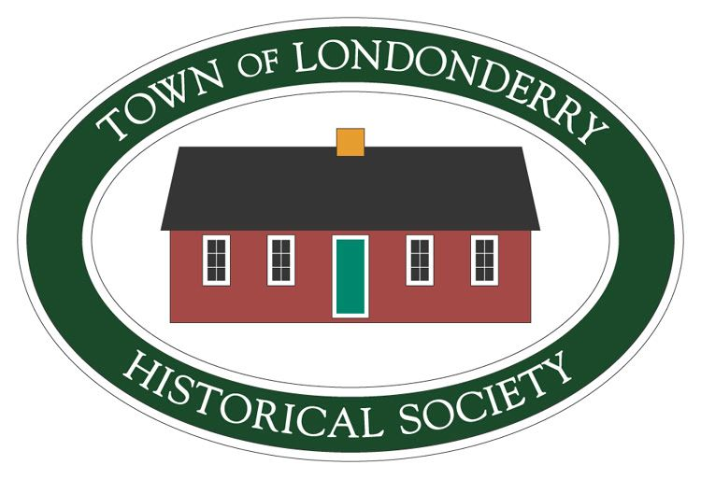
Londonderry Historical Society
Membership Form

Name:__________________________________________________________________________________________________________

Address:________________________________________________________________________________________________________

Phone:__________________________________ E-mail:_______________________________________________________________

How would you like to receive our Newsletter? ______in the mail ______via e-mail

Do you have any interests, experience, information, or hobbies related to history in general or to Londonderry history in particular that you would like us to know about or that you can help us with?_________________________________________________________________________________________________________________________________________________________________________________________________________________________________________________________________________________________________________________________________________________________________________________

Annual membership is $25.00

______Pay by check (payable to Londonderry Historical Society)

Mail to: Membership, Londonderry Historical Society, PO Box 136, Londonderry, NH 03053

OR
______Pay by credit card (MC, VISA, AMEX, Discover)

Name on card:________________________________________________________________________________________________

Card Number:________________________________________________________________________________________________

Expiration Date: __________________________________ security code__________________________________________

Thank you….and please take a minute to fill out the survey on the back of this form.

LHS Member Survey

Which current LHS events/activities do you participate in, if any? (Check all that apply.)

______Monthly meetings ______Old Home Day ______Giving school tours
______Election Day bake sales/merchandise sales ______Caring for buildings and grounds
______Annual Christmas party ______Other (please specify)_____________________________________

What other events/activities would you like to see LHS offer?

Educational programs:
______ Talks on local history, NH history, genealogy, caring for antiques, etc.
______Concerts of traditional music or performances by historic re-enactors
______Other programs (Please give us any suggestions you have.)_______________________________
_________________________________________________________________________________________________________

______Having the Morrison House Museum open regular hours (one weekend/month in the
warm weather, for example)
______Events/activities specifically for children or families
______Discounts for members at area businesses
______Trips for members to other museums or historic sites
______Other ideas (please specify) ___________________________________________________________________________
__________________________________________________________________________________________________________________

What days of the week/times of the day are best for you to attend LHS events?____________________
__________________________________________________________________________________________________________________

Would you be interested in volunteering for the LHS? If so, check which activities would be of interest.
_____Helping plan Old Home Day and other events
_____Being present to assist visitors at LHS events (Old Home Day, rentals, etc.)
_____Giving tours to elementary school students or Cub/Brownie scouts (We will train you.)
_____Giving tours of the Morrison House, barn, or blacksmith shop (We will train you.)
_____Building and facilities maintenance (Having your own tools/equipment helps but
isn’t required.)
_____Editing the Newsletter (usually produced twice a year)
_____Baking and/or helping to sell goods at Election Day bake sales
Do you have any other comments or suggestions?________________________________________________________________
____________________________________________________________________________________________________________________________
__________________________________________________________________________________________________________________________________________________________________________________________________________________________________________________________
Thank you for your feedback!

